**Section 0**

1. Created a project_dir:

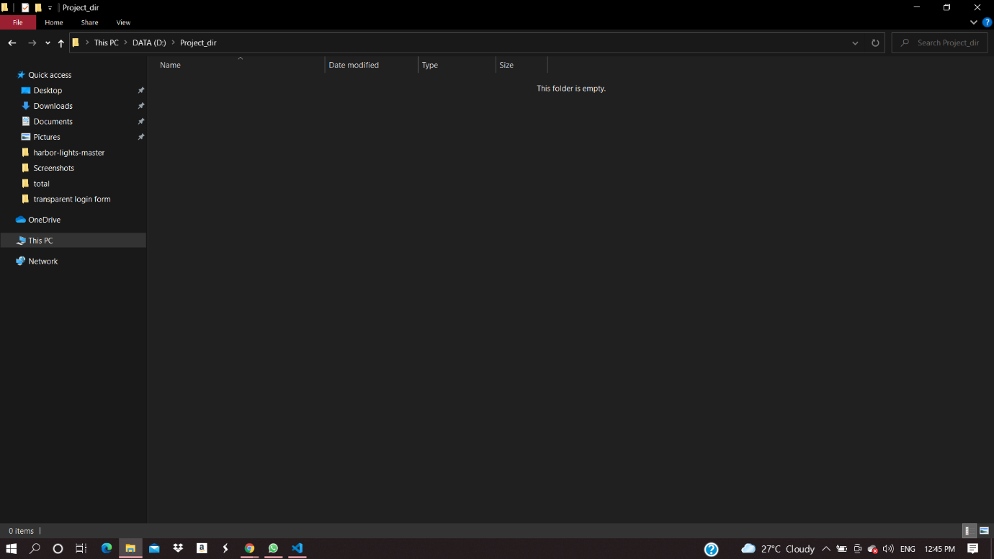

1. Initializing git init:

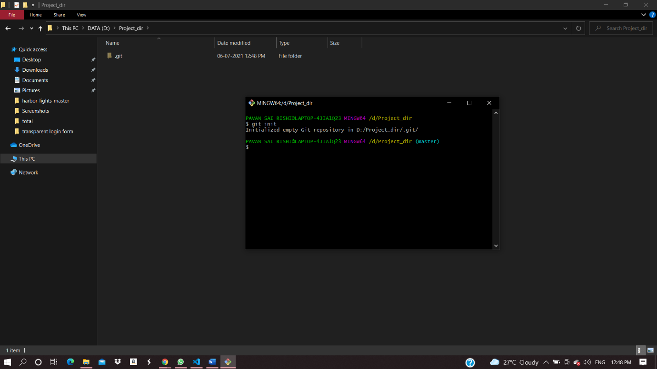

1. Creating a new file index.html:

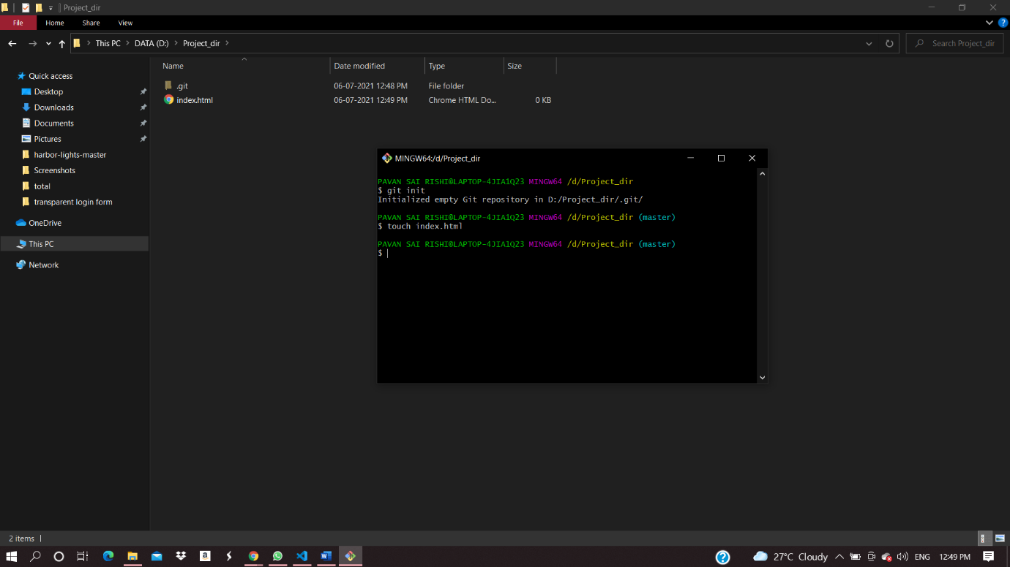

4)checking git status:

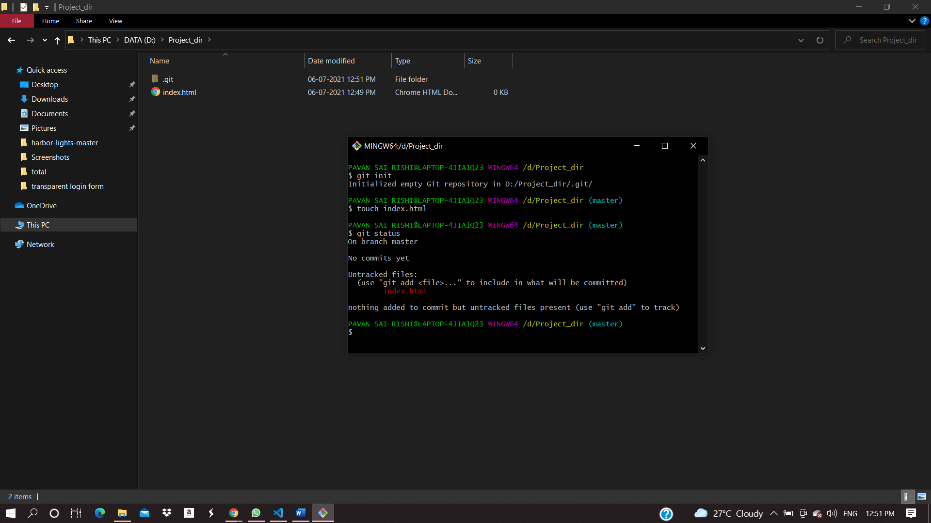

5)staging index.html

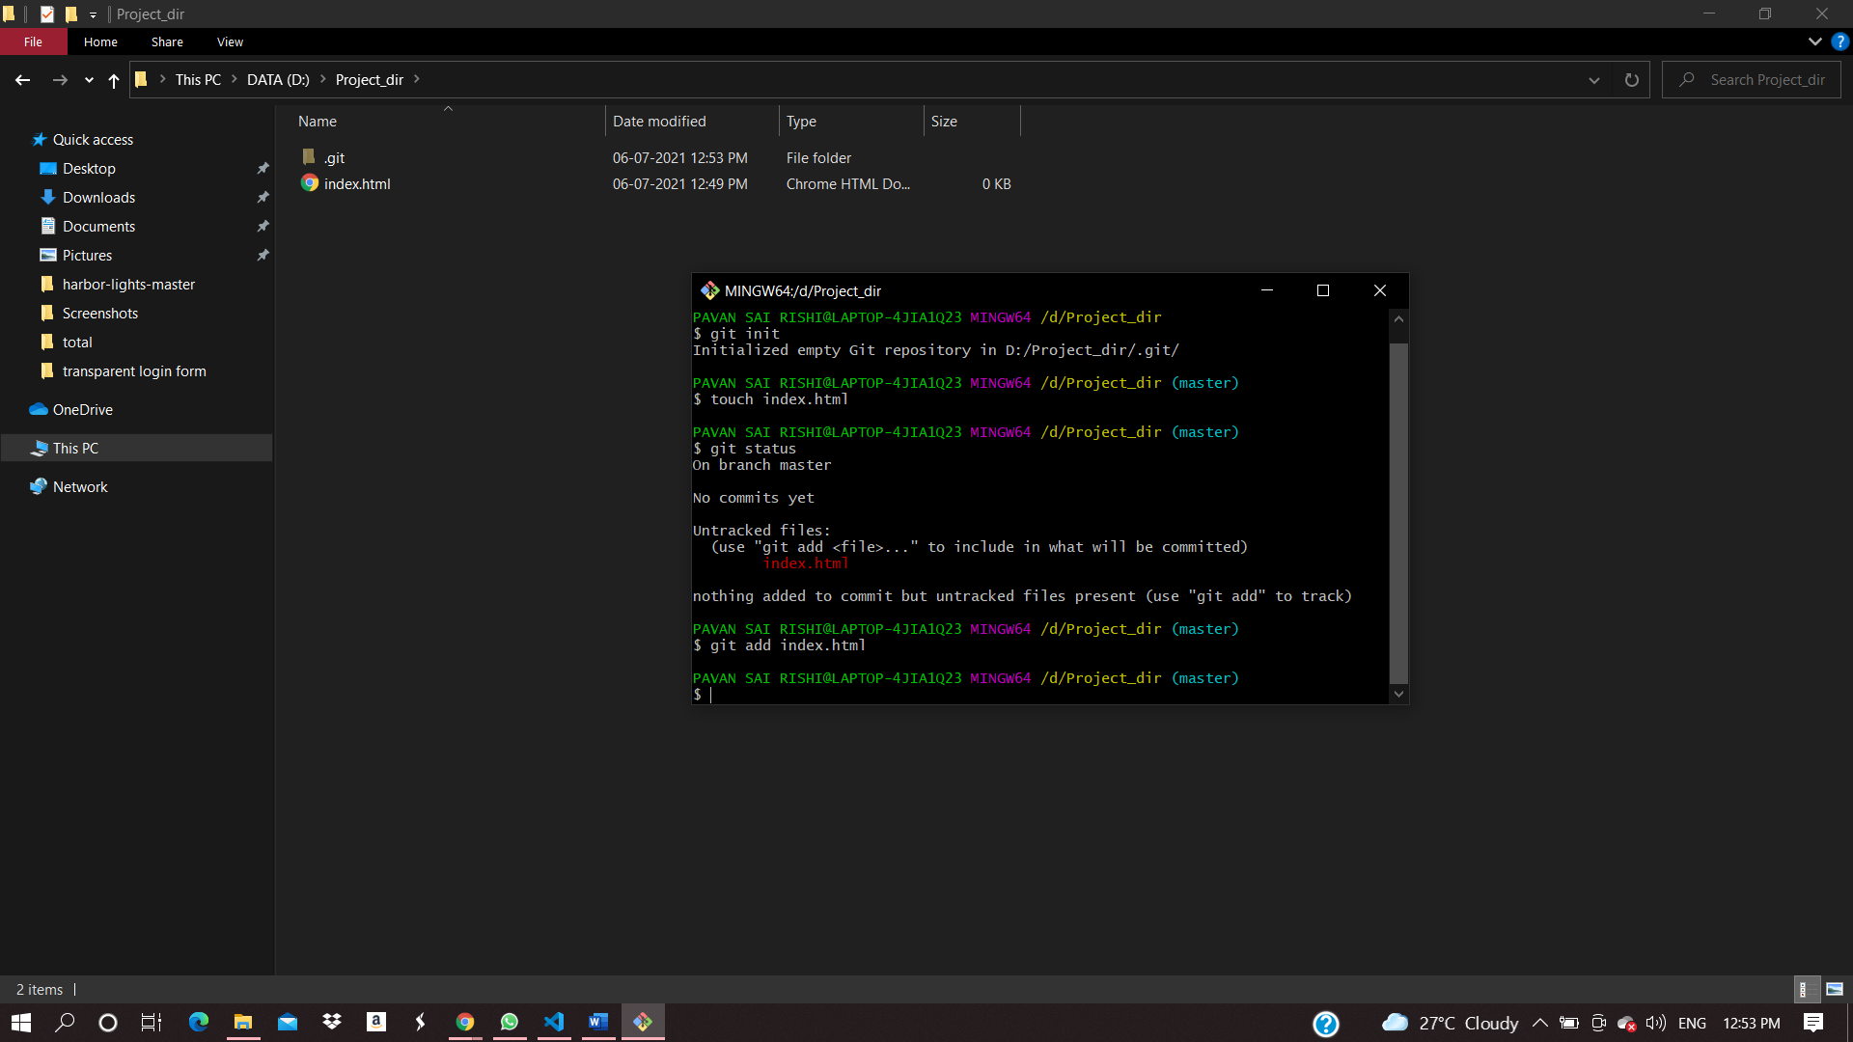

6) commiting the file:

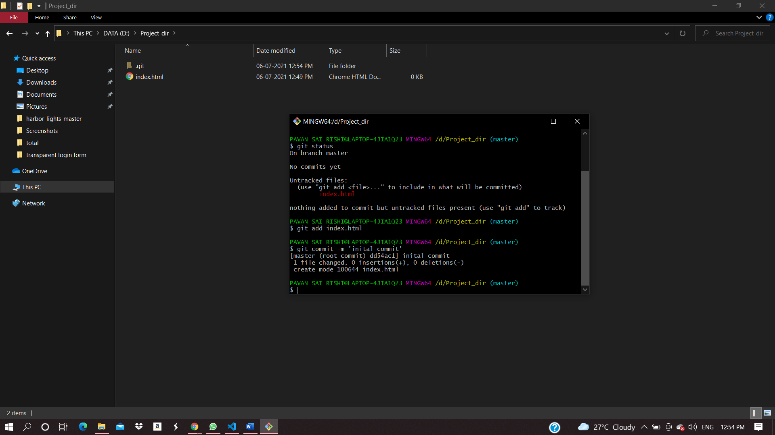

7)changing index.html and creating info.txt file:

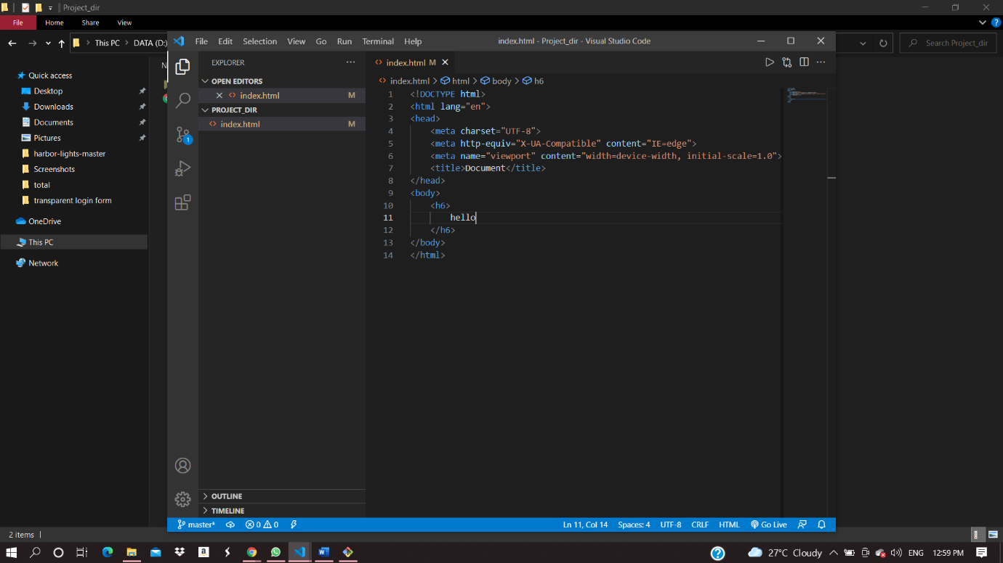

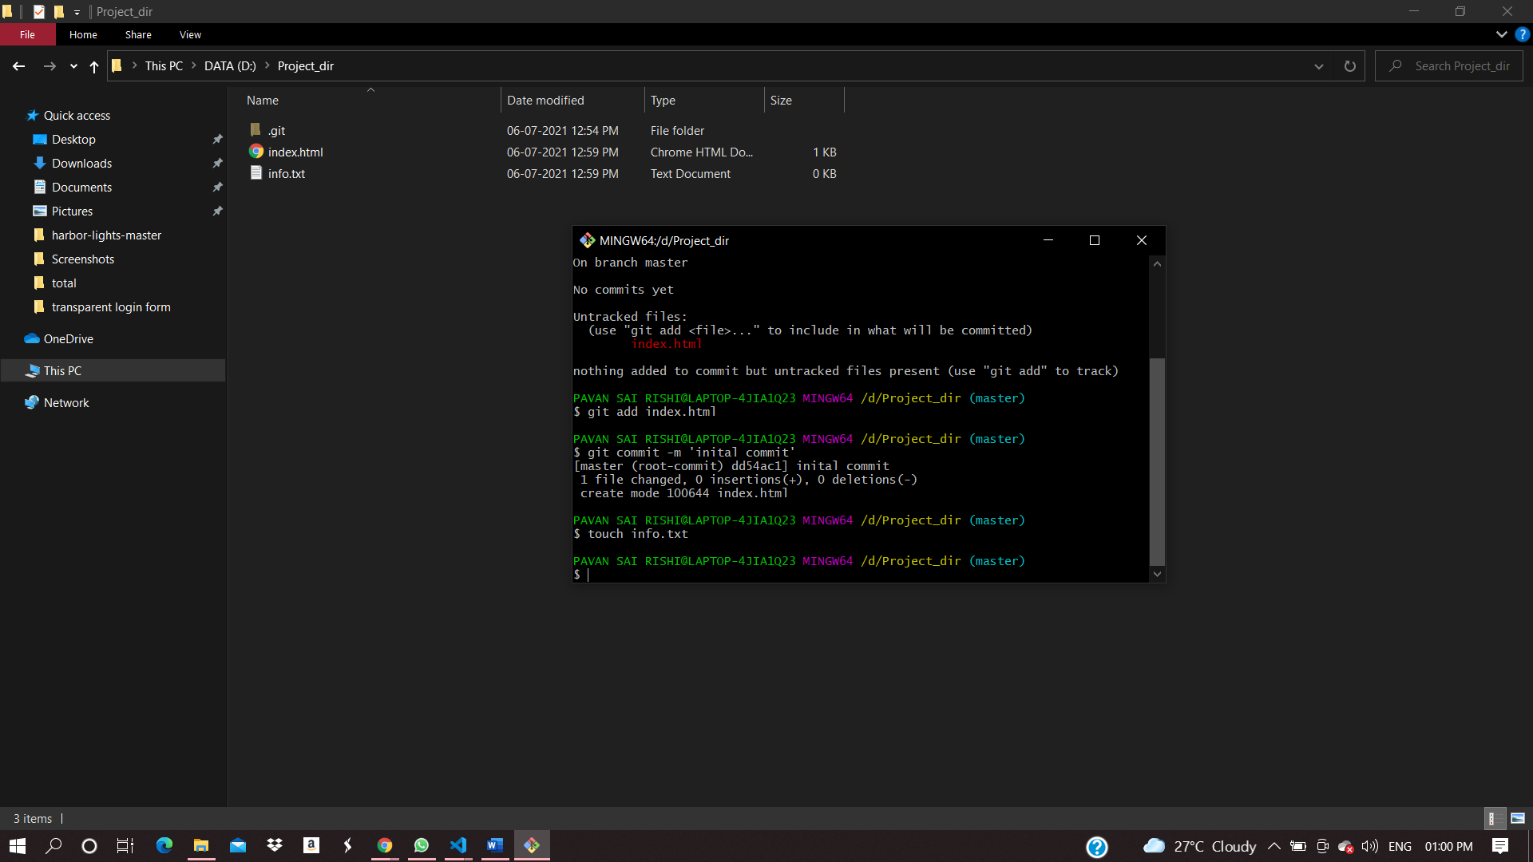

8)checking git status:

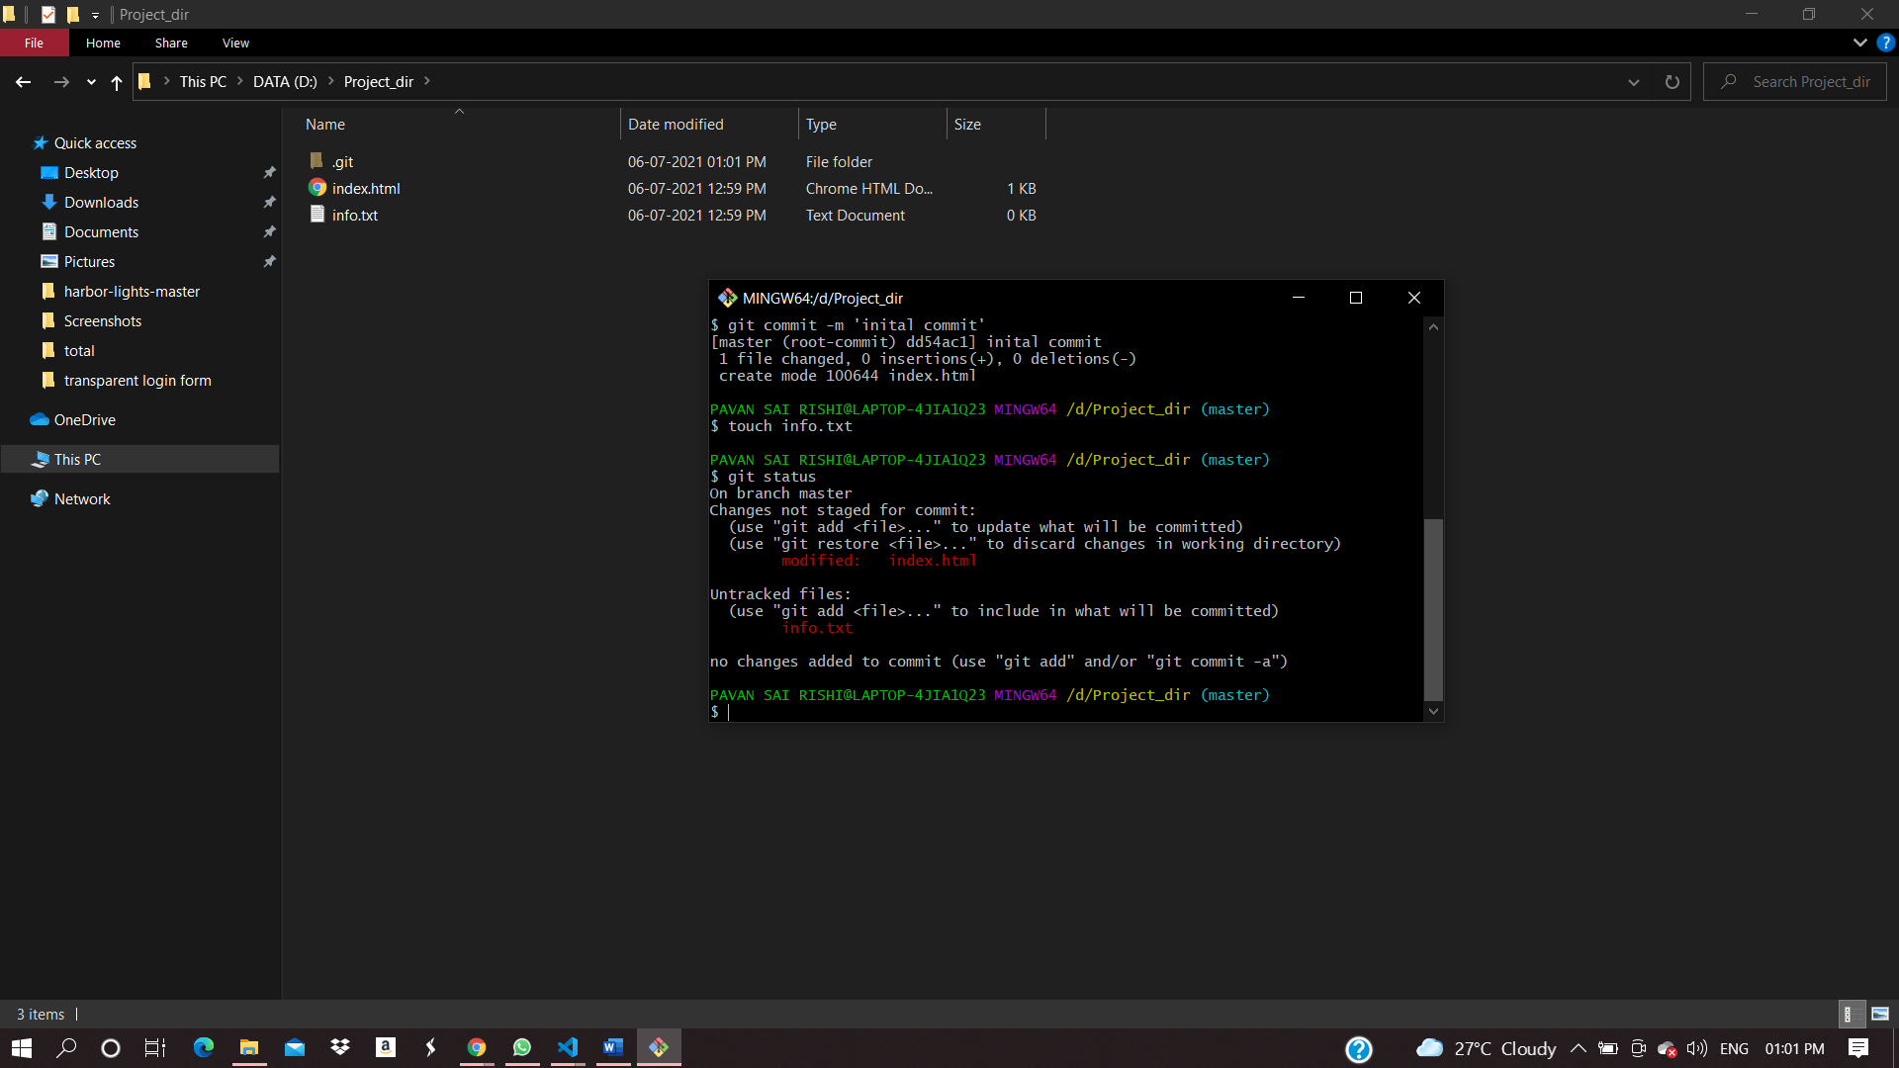

9)configure git to ignore txt files:

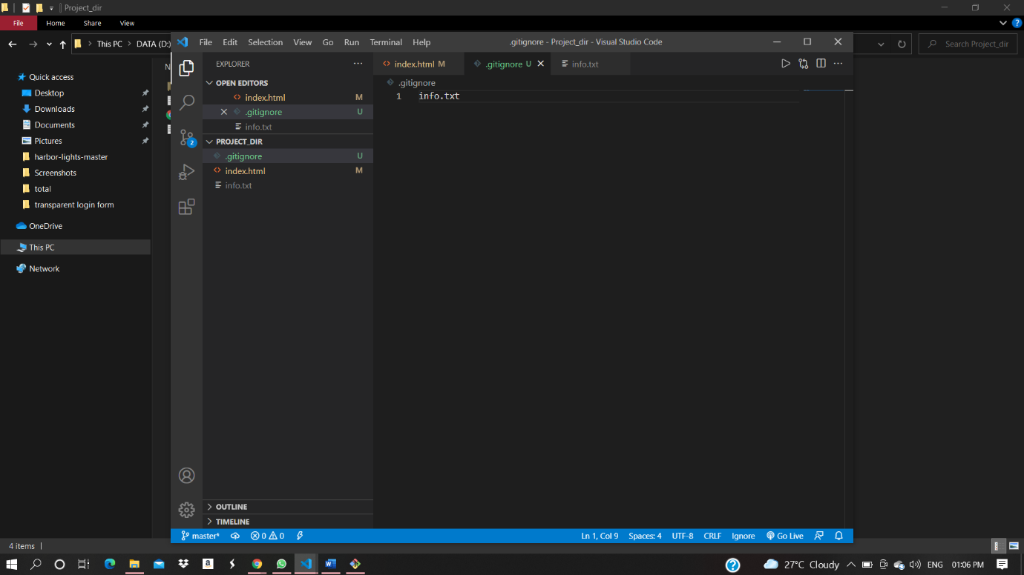

10)git status :

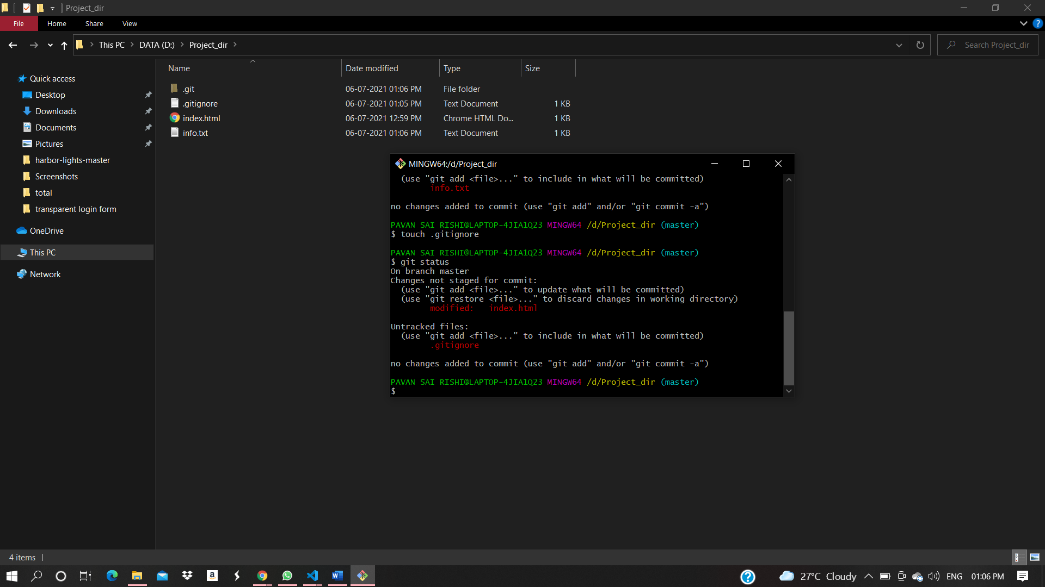

11)state and commit index.html:

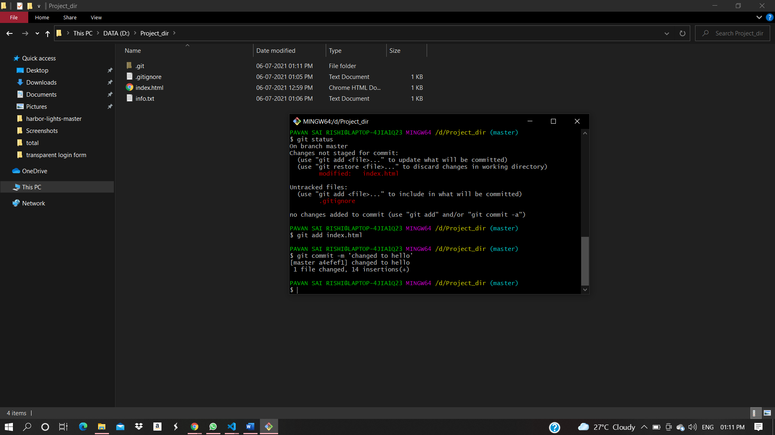

12) comments log:

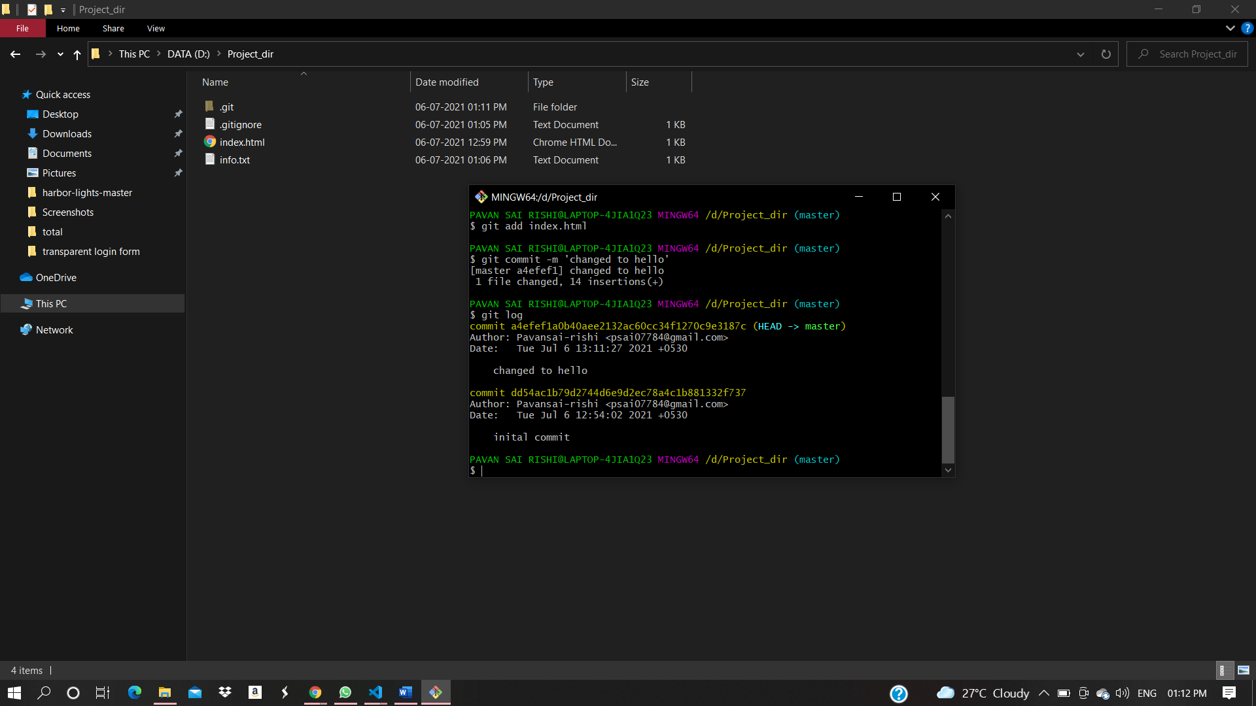

13)changing index file :

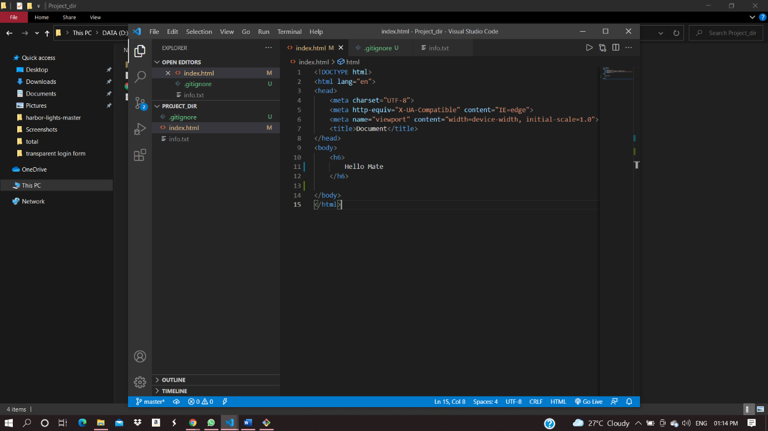

14) reverting the change using git:

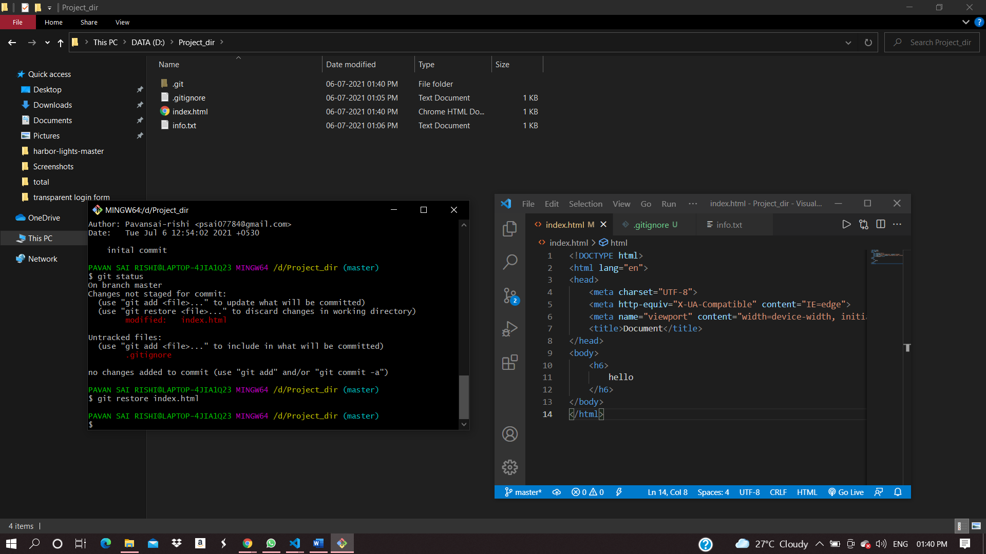

15)Again changing index.html:

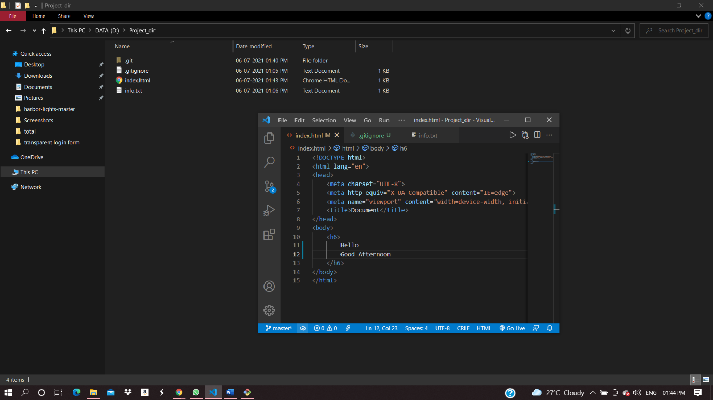

16) stage index.html:

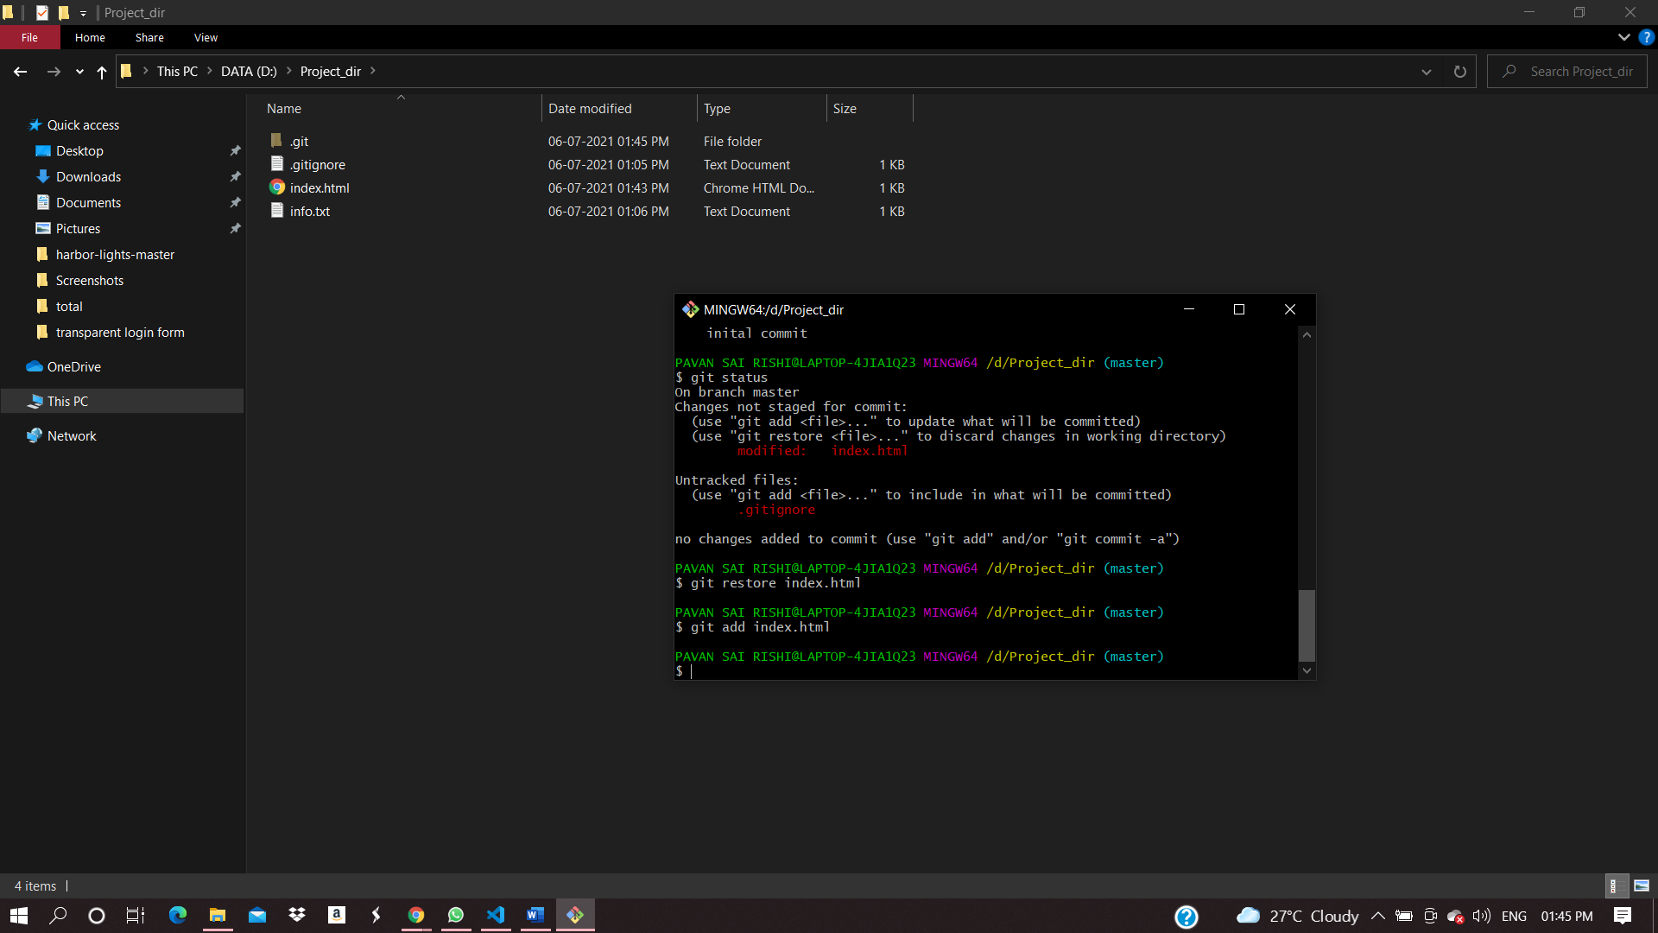

17)revert back the last stage:

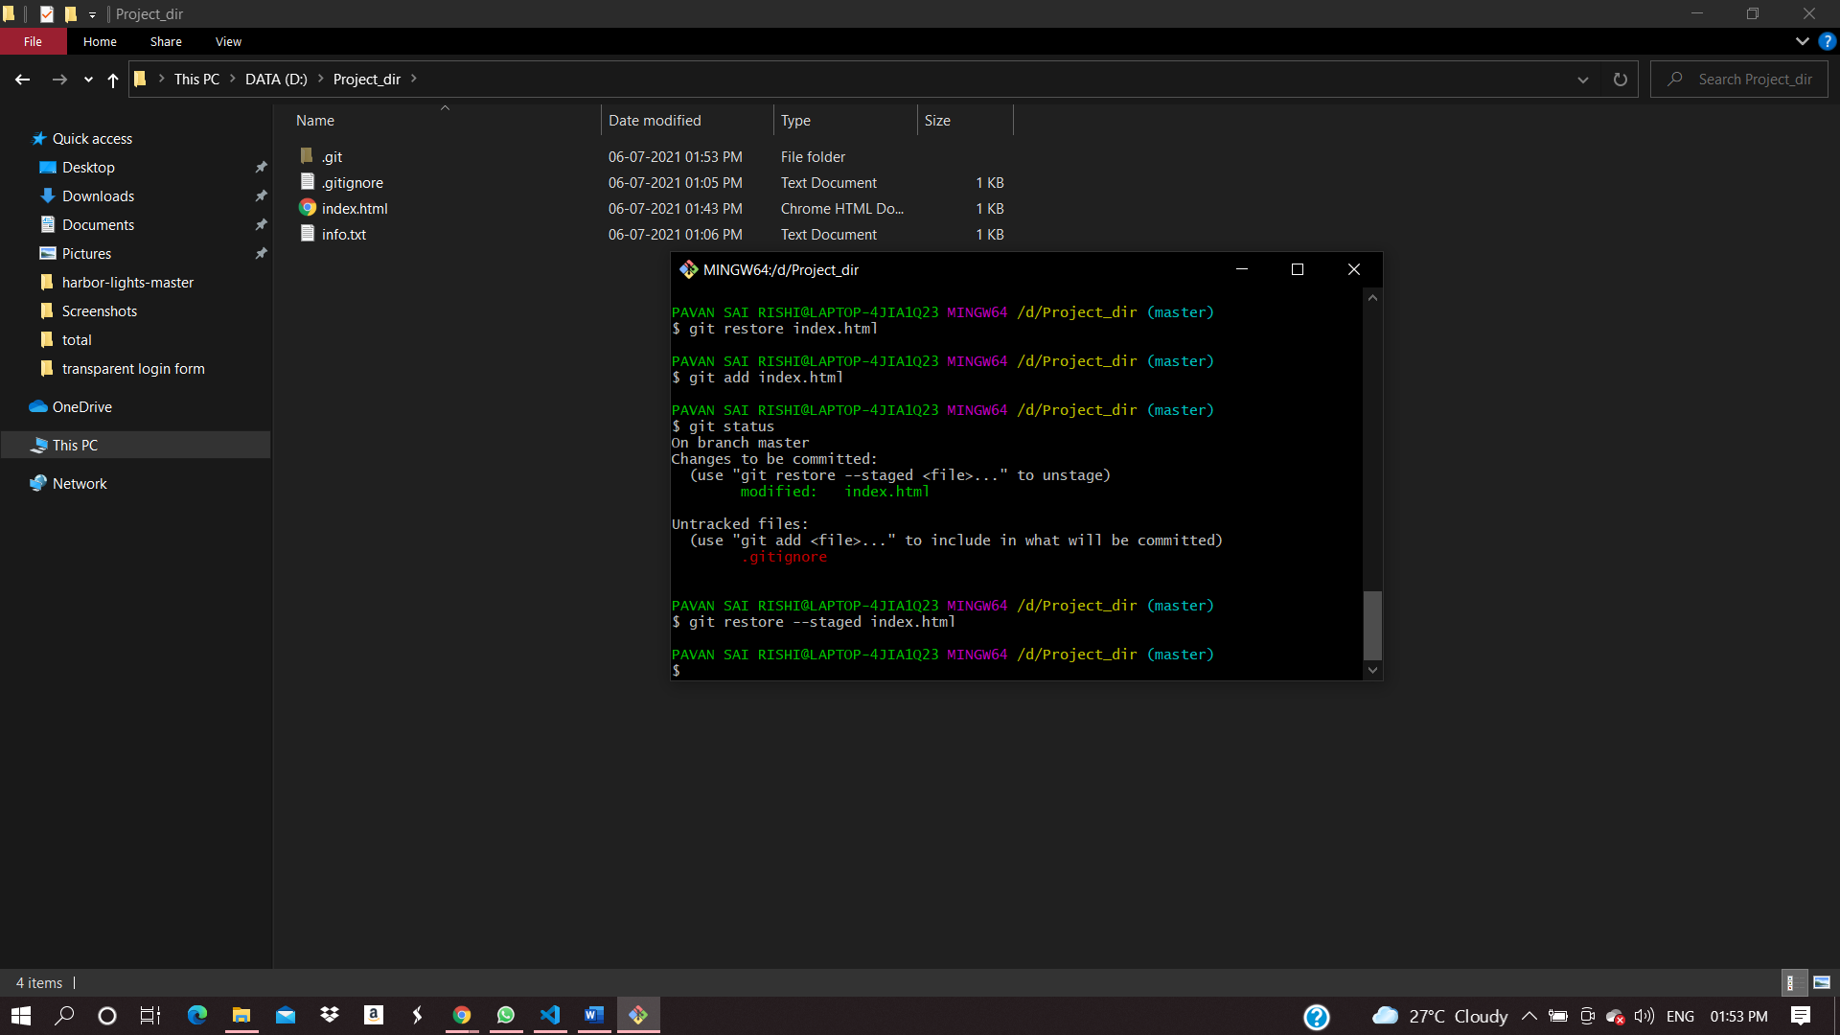

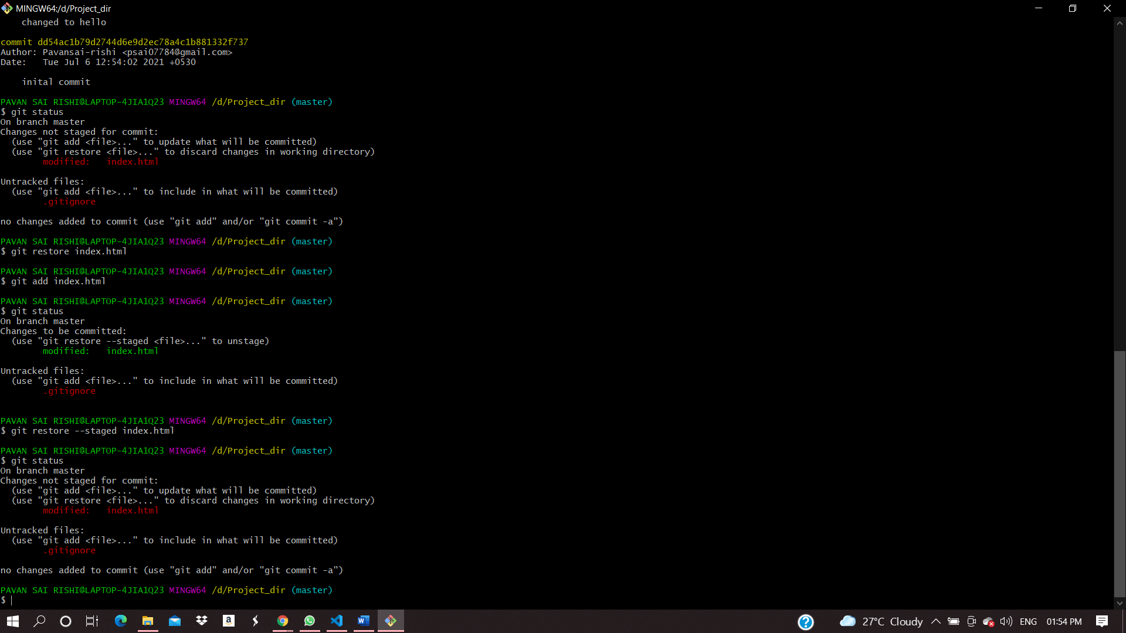

18)rename add command to my-add:

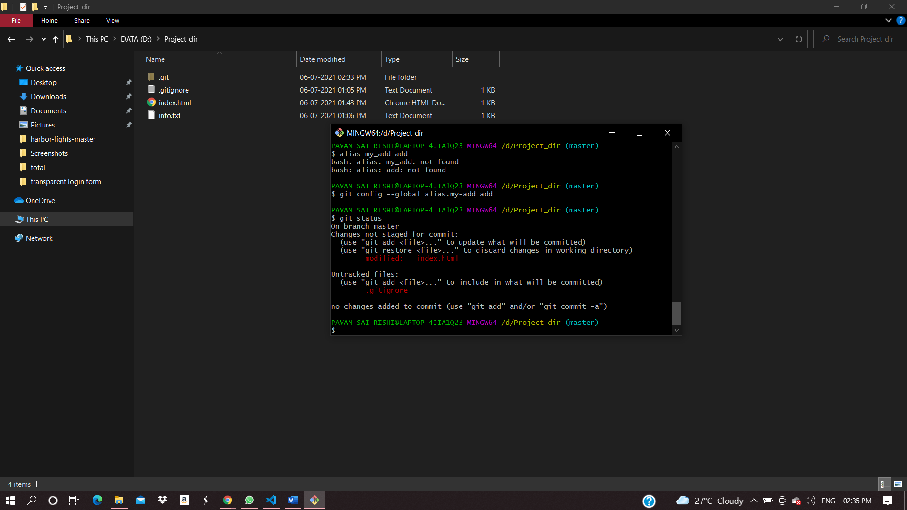

19)stage and commit with my-add:

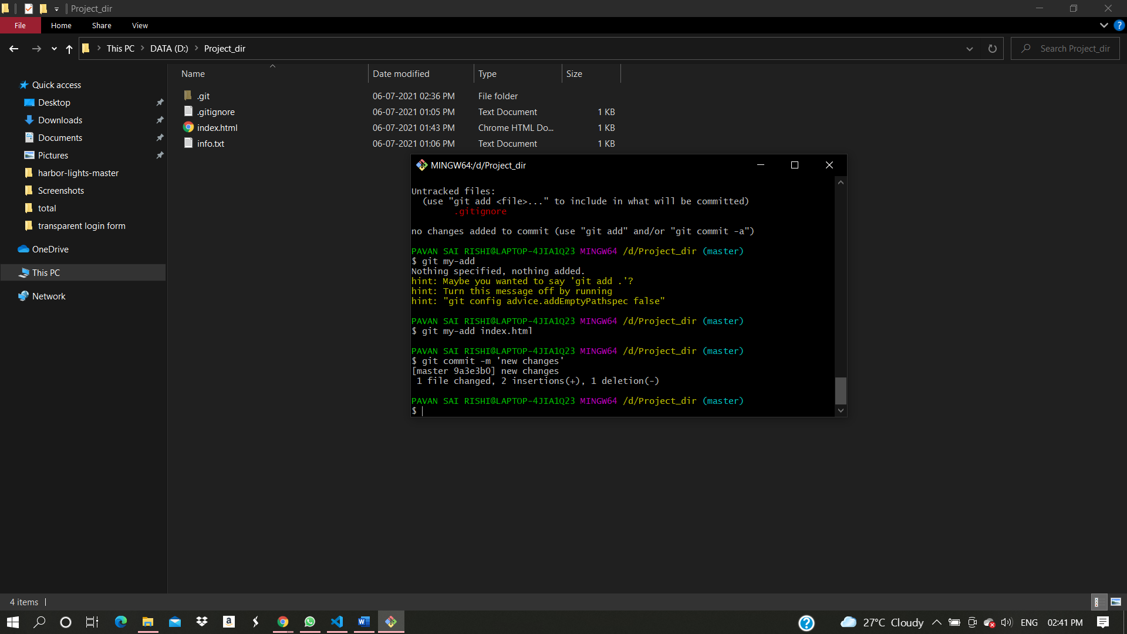

20)revert the last commit:

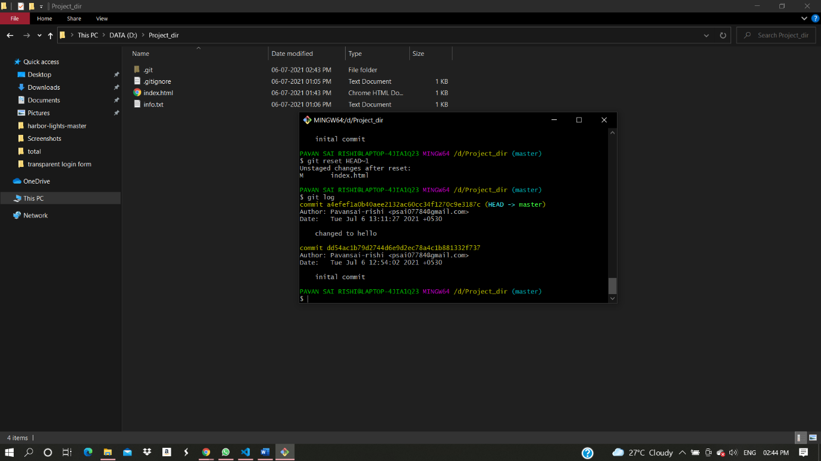

PAVAN SAI RISHI@LAPTOP-4JIA1Q23 MINGW64 /d/Project_dir

$ git init

Initialized empty Git repository in D:/Project_dir/.git/

PAVAN SAI RISHI@LAPTOP-4JIA1Q23 MINGW64 /d/Project_dir (master)

$ touch index.html

PAVAN SAI RISHI@LAPTOP-4JIA1Q23 MINGW64 /d/Project_dir (master)

$ git status

On branch master

No commits yet

Untracked files:

(use "git add <file>..." to include in what will be committed)

index.html

nothing added to commit but untracked files present (use "git add" to track)

PAVAN SAI RISHI@LAPTOP-4JIA1Q23 MINGW64 /d/Project_dir (master)

$ git add index.html

PAVAN SAI RISHI@LAPTOP-4JIA1Q23 MINGW64 /d/Project_dir (master)

$ git commit -m 'inital commit'

[master (root-commit) dd54ac1] inital commit

1 file changed, 0 insertions(+), 0 deletions(-)

create mode 100644 index.html

PAVAN SAI RISHI@LAPTOP-4JIA1Q23 MINGW64 /d/Project_dir (master)

$ touch info.txt

PAVAN SAI RISHI@LAPTOP-4JIA1Q23 MINGW64 /d/Project_dir (master)

$ git status

On branch master

Changes not staged for commit:

(use "git add <file>..." to update what will be committed)

(use "git restore <file>..." to discard changes in working directory)

modified: index.html

Untracked files:

(use "git add <file>..." to include in what will be committed)

info.txt

no changes added to commit (use "git add" and/or "git commit -a")

PAVAN SAI RISHI@LAPTOP-4JIA1Q23 MINGW64 /d/Project_dir (master)

$ touch .gitignore

PAVAN SAI RISHI@LAPTOP-4JIA1Q23 MINGW64 /d/Project_dir (master)

$ git status

On branch master

Changes not staged for commit:

(use "git add <file>..." to update what will be committed)

(use "git restore <file>..." to discard changes in working directory)

modified: index.html

Untracked files:

(use "git add <file>..." to include in what will be committed)

.gitignore

no changes added to commit (use "git add" and/or "git commit -a")

PAVAN SAI RISHI@LAPTOP-4JIA1Q23 MINGW64 /d/Project_dir (master)

$ git add index.html

PAVAN SAI RISHI@LAPTOP-4JIA1Q23 MINGW64 /d/Project_dir (master)

$ git commit -m 'changed to hello'

[master a4efef1] changed to hello

1 file changed, 14 insertions(+)

PAVAN SAI RISHI@LAPTOP-4JIA1Q23 MINGW64 /d/Project_dir (master)

$ git log

commit a4efef1a0b40aee2132ac60cc34f1270c9e3187c (HEAD -> master)

Author: Pavansai-rishi <psai07784@gmail.com>

Date: Tue Jul 6 13:11:27 2021 +0530

changed to hello

commit dd54ac1b79d2744d6e9d2ec78a4c1b881332f737

Author: Pavansai-rishi <psai07784@gmail.com>

Date: Tue Jul 6 12:54:02 2021 +0530

inital commit

PAVAN SAI RISHI@LAPTOP-4JIA1Q23 MINGW64 /d/Project_dir (master)

$ git status

On branch master

Changes not staged for commit:

(use "git add <file>..." to update what will be committed)

(use "git restore <file>..." to discard changes in working directory)

modified: index.html

Untracked files:

(use "git add <file>..." to include in what will be committed)

.gitignore

no changes added to commit (use "git add" and/or "git commit -a")

PAVAN SAI RISHI@LAPTOP-4JIA1Q23 MINGW64 /d/Project_dir (master)

$ git restore index.html

PAVAN SAI RISHI@LAPTOP-4JIA1Q23 MINGW64 /d/Project_dir (master)

$ git add index.html

PAVAN SAI RISHI@LAPTOP-4JIA1Q23 MINGW64 /d/Project_dir (master)

$ git status

On branch master

Changes to be committed:

(use "git restore --staged <file>..." to unstage)

modified: index.html

Untracked files:

(use "git add <file>..." to include in what will be committed)

.gitignore

PAVAN SAI RISHI@LAPTOP-4JIA1Q23 MINGW64 /d/Project_dir (master)

$ git restore --staged index.html

PAVAN SAI RISHI@LAPTOP-4JIA1Q23 MINGW64 /d/Project_dir (master)

$ git status

On branch master

Changes not staged for commit:

(use "git add <file>..." to update what will be committed)

(use "git restore <file>..." to discard changes in working directory)

modified: index.html

Untracked files:

(use "git add <file>..." to include in what will be committed)

.gitignore

no changes added to commit (use "git add" and/or "git commit -a")

PAVAN SAI RISHI@LAPTOP-4JIA1Q23 MINGW64 /d/Project_dir (master)

$ git config --global alias.my-add add

PAVAN SAI RISHI@LAPTOP-4JIA1Q23 MINGW64 /d/Project_dir (master)

$ git status

On branch master

Changes not staged for commit:

(use "git add <file>..." to update what will be committed)

(use "git restore <file>..." to discard changes in working directory)

modified: index.html

Untracked files:

(use "git add <file>..." to include in what will be committed)

.gitignore

no changes added to commit (use "git add" and/or "git commit -a")

PAVAN SAI RISHI@LAPTOP-4JIA1Q23 MINGW64 /d/Project_dir (master)

$ git my-add index.html

PAVAN SAI RISHI@LAPTOP-4JIA1Q23 MINGW64 /d/Project_dir (master)

$ git commit -m 'new changes'

[master 9a3e3b0] new changes

1 file changed, 2 insertions(+), 1 deletion(-)

PAVAN SAI RISHI@LAPTOP-4JIA1Q23 MINGW64 /d/Project_dir (master)

$ git log

commit 9a3e3b0655f8e9a79e729d1c9161aa5f67bb0aac (HEAD -> master)

Author: Pavansai-rishi <psai07784@gmail.com>

Date: Tue Jul 6 14:36:55 2021 +0530

new changes

commit a4efef1a0b40aee2132ac60cc34f1270c9e3187c

Author: Pavansai-rishi <psai07784@gmail.com>

Date: Tue Jul 6 13:11:27 2021 +0530

changed to hello

commit dd54ac1b79d2744d6e9d2ec78a4c1b881332f737

Author: Pavansai-rishi <psai07784@gmail.com>

Date: Tue Jul 6 12:54:02 2021 +0530

inital commit

PAVAN SAI RISHI@LAPTOP-4JIA1Q23 MINGW64 /d/Project_dir (master)

$ git reset HEAD~1

Unstaged changes after reset:

M index.html

PAVAN SAI RISHI@LAPTOP-4JIA1Q23 MINGW64 /d/Project_dir (master)

$ git log

commit a4efef1a0b40aee2132ac60cc34f1270c9e3187c (HEAD -> master)

Author: Pavansai-rishi <psai07784@gmail.com>

Date: Tue Jul 6 13:11:27 2021 +0530

changed to hello

commit dd54ac1b79d2744d6e9d2ec78a4c1b881332f737

Author: Pavansai-rishi <psai07784@gmail.com>

Date: Tue Jul 6 12:54:02 2021 +0530

inital commit